实验三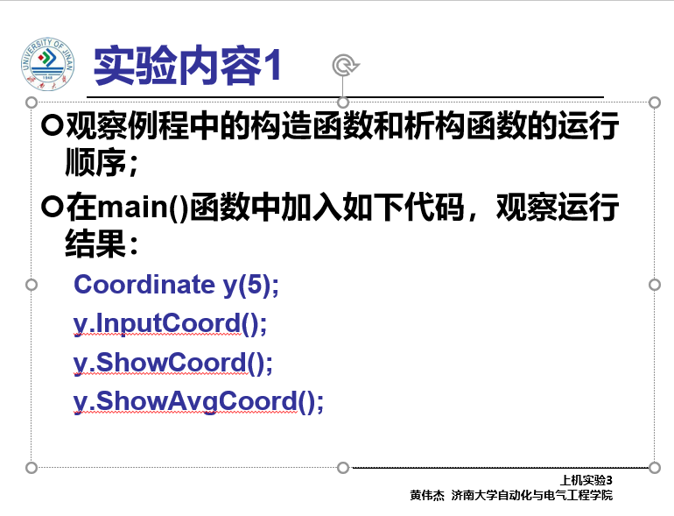

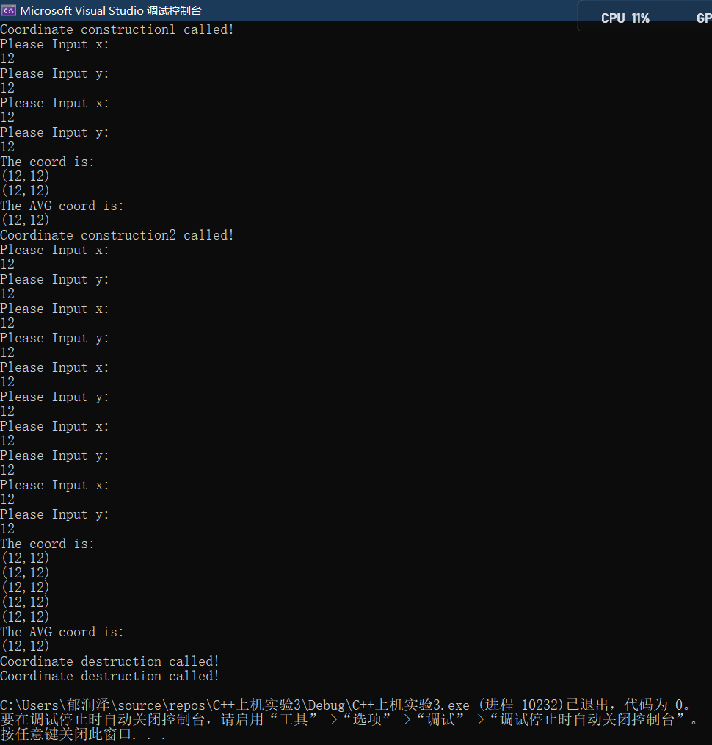

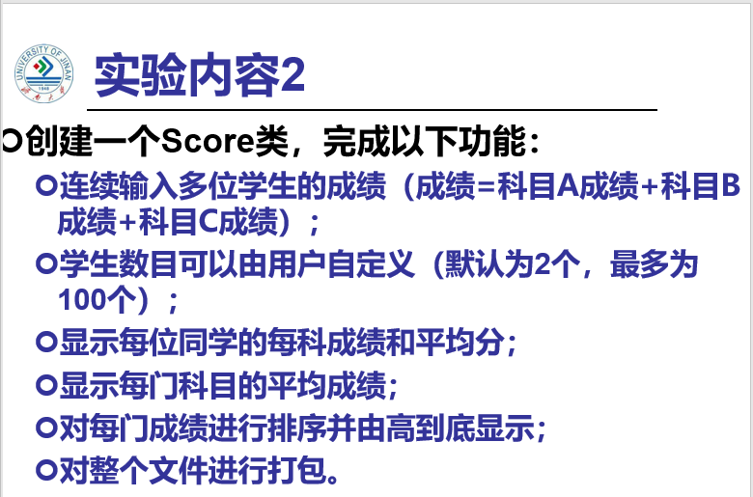

#include<iostream>

using namespace std;

class Score

{

public:

Score()

{

times = 2;

cout << "请输入成绩单：" << endl;

}=

Score(int times1)

{

times = times1;

cout << "请输入学生成绩" << endl;

}=

void InputScores()

{

for (int i = 0; i < times; i++)

{

cout << "请输入学生姓名:" << endl;

cin >> Scores[i][0];

cout << "请输入科目A成绩:" << endl;

cin >> Scores[i][1];

cout << "请输入科目B成绩:" << endl;

cin >> Scores[i][2];

cout << "请输入科目C成绩:" << endl;

cin >> Scores[i][3];

}

}

void ShowScores()

{

cout << "成绩表如下:" << endl;

for (int i = 0; i < times; i++)

{

cout << "姓名:" << Scores[i][0] << " 科目A成绩：" << Scores[i][1] << " 科目B成绩：" << Scores[i][2] << " 科目C成绩：" << Scores[i][3] << endl;

}

}

void ShowAvgScores()

{

float avgA = 0;

float avgB = 0;

float avgC = 0;

for (int i = 0; i < times; i++)

{

avgA = avgA + Scores[i][1];

avgB = avgB + Scores[i][2];

avgC = avgC + Scores[i][3];

}

avgA = avgA / times;

avgB = avgB / times;

avgC = avgC / times;

cout << "各科目平均成绩:" << endl;

cout << "科目A平均成绩：" << avgA << " 科目B平均成绩：" << avgB << " 科目C平均成绩：" <<avgC<< endl;

}

void Showmakers()

{

float mixA = 0;

float mixB = 0;

float mixC = 0;

float minA = 0;

float minB = 0;

float minC = 0;

if (Scores[0][1] <= Scores[1][1])

{

mixA = Scores[1][1];

minA = Scores[0][1];

cout << "科目A:" << endl;

cout << "姓名:" << Scores[1][0] << " 成绩："<< Scores[1][1] << endl;

cout << "姓名:" << Scores[0][0] << " 成绩："<< Scores[0][1] << endl;

}

else if (Scores[0][1] > Scores[1][1])

{

mixA = Scores[0][1];

minA = Scores[1][1];

cout << "科目A:" << endl;

cout << "姓名:" << Scores[0][0] << " 成绩：" << Scores[0][1] << endl;

cout << "姓名:" << Scores[1][0] << " 成绩：" << Scores[1][1] << endl;

}

if (Scores[0][2] <= Scores[1][2])

{

mixA = Scores[1][2];

minA = Scores[0][2];

cout << "科目B:" << endl;

cout << "姓名:" << Scores[1][0] << " 成绩：" << Scores[1][2] << endl;

cout << "姓名:" << Scores[0][0] << " 成绩：" << Scores[0][2] << endl;

}

else if (Scores[0][2] > Scores[1][2])

{

mixA = Scores[0][2];

minA = Scores[1][2];

cout << "科目B:" << endl;

cout << "姓名:" << Scores[0][0] << " 成绩：" << Scores[0][2] << endl;

cout << "姓名:" << Scores[1][0] << " 成绩：" << Scores[1][2] << endl;

}

if (Scores[0][3] <= Scores[1][3])

{

mixA = Scores[1][3];

minA = Scores[0][3];

cout << "科目C:" << endl;

cout << "姓名:" << Scores[1][0] << " 成绩：" << Scores[1][3] << endl;

cout << "姓名:" << Scores[0][0] << " 成绩：" << Scores[0][3] << endl;

}

else if (Scores[0][3] > Scores[1][3])

{

mixA = Scores[0][3];

minA = Scores[1][3];

cout << "科目C:" << endl;

cout << "姓名:" << Scores[0][0] << " 成绩：" << Scores[0][3] << endl;

cout << "姓名:" << Scores[1][0] << " 成绩：" << Scores[1][3] << endl;

}

}

private:

float Scores[100][100];

int times;

};

int main()

{

Score x;

x.InputScores();

x.ShowScores();

x.ShowAvgScores();

x.Showmakers();

return 0;

}

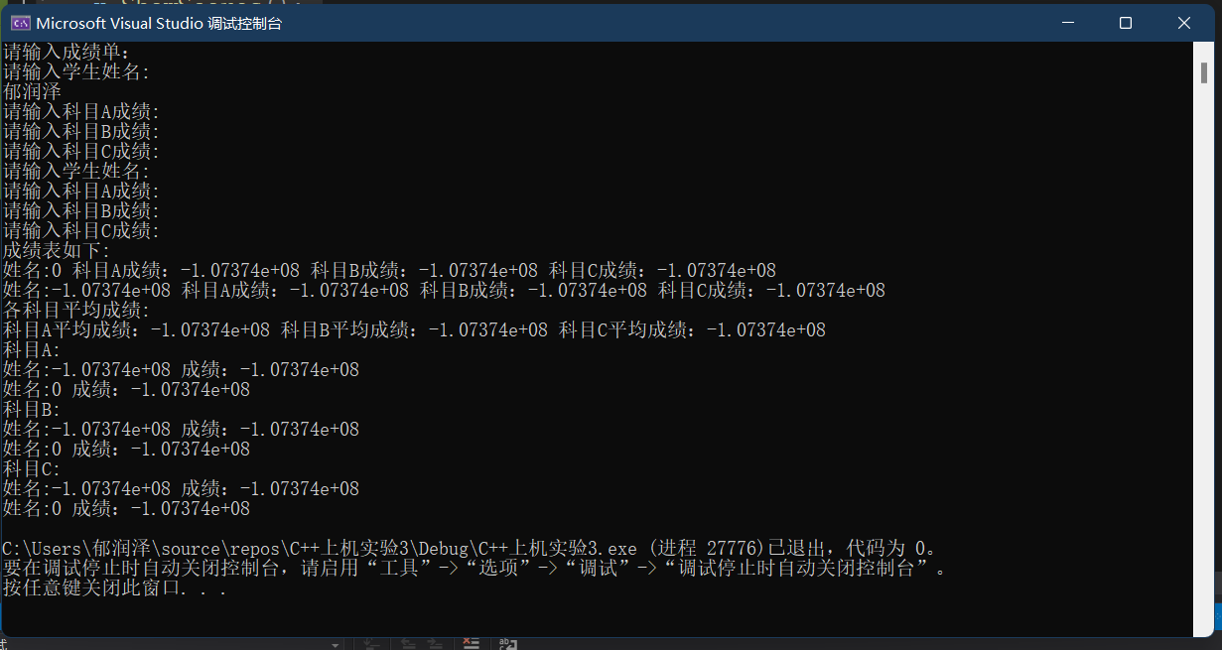

出现问题：输入汉字后程序自动执行结束，输入数字无错。

解决方法：单列name，上面改为name[]，下面改为name[][].

# 程序代码

#include<iostream>

using namespace std;

class Score

{

public:

Score()

{

times = 2;

cout << "请输入成绩单：" << endl;

}

Score(int times1)

{

times = times1;

cout << "请输入学生成绩" << endl;

}

void InputScores()

{

for (int i = 0; i < times; i++)

{

cout << "请输入学生姓名:" << endl;

cin >> name[i];

cout << "请输入科目A成绩:" << endl;

cin >> Scores[i][1];

cout << "请输入科目B成绩:" << endl;

cin >> Scores[i][2];

cout << "请输入科目C成绩:" << endl;

cin >> Scores[i][3];

}

}

void ShowScores()

{

cout << "成绩表如下:" << endl;

for (int i = 0; i < times; i++)

{

cout << "姓名:" << name[i] << " 科目A成绩：" << Scores[i][1] << " 科目B成绩：" << Scores[i][2] << " 科目C成绩：" << Scores[i][3] << endl;

}

}

void ShowAvgScores()

{

float avgA = 0;

float avgB = 0;

float avgC = 0;

for (int i = 0; i < times; i++)

{

avgA = avgA + Scores[i][1];

avgB = avgB + Scores[i][2];

avgC = avgC + Scores[i][3];

}

avgA = avgA / times;

avgB = avgB / times;

avgC = avgC / times;

cout << "各科目平均成绩:" << endl;

cout << "科目A平均成绩：" << avgA << " 科目B平均成绩：" << avgB << " 科目C平均成绩：" <<avgC<< endl;

}

void Showmakers()

{

float mixA = 0;

float mixB = 0;

float mixC = 0;

float minA = 0;

float minB = 0;

float minC = 0;

if (Scores[0][1] <= Scores[1][1])

{

mixA = Scores[1][1];

minA = Scores[0][1];

cout << "科目A:" << endl;

cout << "姓名:" << name[1] << " 成绩："<< Scores[1][1] << endl;

cout << "姓名:" << name[0] << " 成绩："<< Scores[0][1] << endl;

}

else if (Scores[0][1] > Scores[1][1])

{

mixA = Scores[0][1];

minA = Scores[1][1];

cout << "科目A:" << endl;

cout << "姓名:" << name[0] << " 成绩：" << Scores[0][1] << endl;

cout << "姓名:" << name[1] << " 成绩：" << Scores[1][1] << endl;

}

if (Scores[0][2] <= Scores[1][2])

{

mixA = Scores[1][2];

minA = Scores[0][2];

cout << "科目B:" << endl;

cout << "姓名:" << name[1] << " 成绩：" << Scores[1][2] << endl;

cout << "姓名:" << name[0] << " 成绩：" << Scores[0][2] << endl;

}

else if (Scores[0][2] > Scores[1][2])

{

mixA = Scores[0][2];

minA = Scores[1][2];

cout << "科目B:" << endl;

cout << "姓名:" << name[0] << " 成绩：" << Scores[0][2] << endl;

cout << "姓名:" << name[1] << " 成绩：" << Scores[1][2] << endl;

}

if (Scores[0][3] <= Scores[1][3])

{

mixA = Scores[1][3];

minA = Scores[0][3];

cout << "科目C:" << endl;

cout << "姓名:" << name[1] << " 成绩：" << Scores[1][3] << endl;

cout << "姓名:" << name[0] << " 成绩：" << Scores[0][3] << endl;

}

else if (Scores[0][3] > Scores[1][3])

{

mixA = Scores[0][3];

minA = Scores[1][3];

cout << "科目C:" << endl;

cout << "姓名:" << name[0] << " 成绩：" << Scores[0][3] << endl;

cout << "姓名:" << name[1] << " 成绩：" << Scores[1][3] << endl;

}

}

private:

float Scores[100][100];

char name[100][100];

int times;

};

int main()

{

Score x;

x.InputScores();

x.ShowScores();

x.ShowAvgScores();

x.Showmakers();

return 0;

}

下面还有

# 程序结果

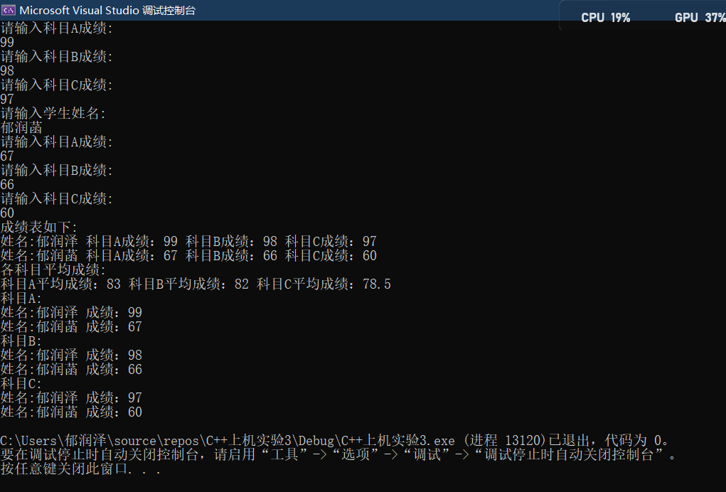

# 程序感想

加深了对类和对象的理解，在实践中掌握了析构函数和构造函数的用法

Copyright ©2021-2099 RunzeYu. All rights reserved